STENCIL 8 WELCOME SECTION: PREPOSITIONS OF PLACE

Terms | Definitions
- The cat is behind the bowl.  - (ACHTER) | 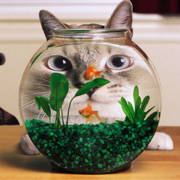  Where is the cat?
- The cat is behind the soccer ball.  - (ACHTER) | 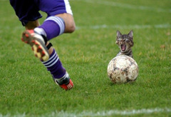  Where is the cat?
- The ball is between their heads.  - (TUSSEN) | 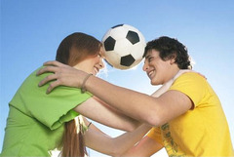  Where is the ball?
- The soccer ball is between the men.  - (TUSSEN) | 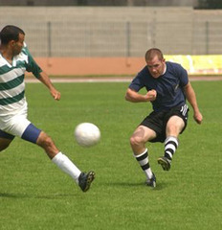  Where is the soccer ball?
- The boy is between the man and the woman.  - (TUSSEN) | 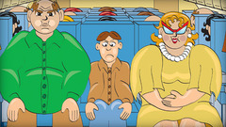  Where is the boy?
- The kitten is between the puppies.  - (TUSSEN) | 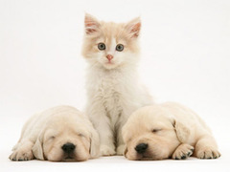  Where is the kitten?
- The woman is between the two boys.  - (TUSSEN) | 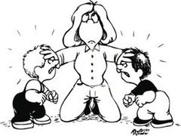  Where is the woman?
- The snowman is in front of the car.  - (VOOR) | 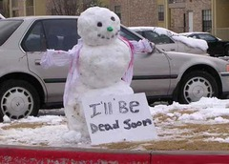  Where is the snowman?
- The woman is in front of the fire.  - (VOOR) | 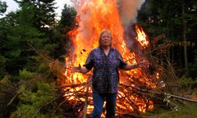  Where is the woman?
- The bird is in the water.  - (IN) | 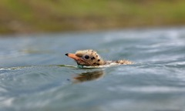  Where is the bird?
- The cat is in the bag.  - (IN) | 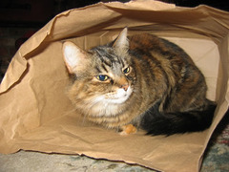  Where is the cat?
- The cat is in the box.  - (IN) | 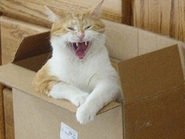  Where is the cat?
- The cats are in the bowl.  - (IN) | 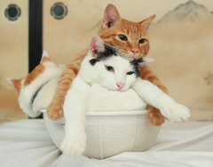  Where are the cats?
- The cats are in the boxes.  - (IN) | 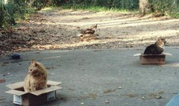  Where are the cats?
- The fish is in the fishbowl.  - (IN) | 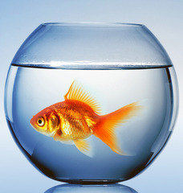  Where is the fish?
- The pencils are in the pencil case.  - (IN) | 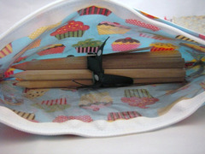  Where are the pencils?
- The cat is next to the bowl.  - (NAAST) | 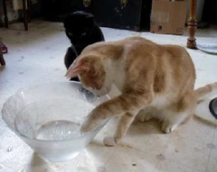  Where is the cat?
- The cat is next to the box.  - (NAAST) | 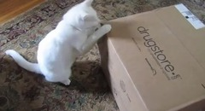  Where is the cat?
- The cat is next to the tree.  - (NAAST) | 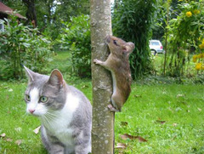  Where is the cat?
- The dog is next to the statue.  - (NAAST) | 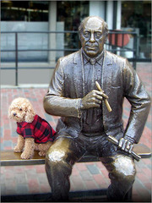  Where is the dog?
- The penguin is next to the giraffe.  - (NAAST) | 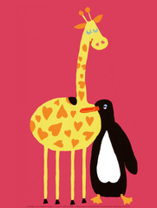  Where is the penguin?
- The pencils are next to the pencil case.  - (NAAST) | 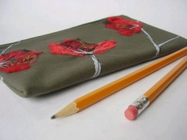  Where are the pencils?
- The kitten is next to the rabbit.  - (NAAST) | 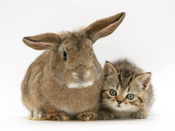  Where is the kitten?
- Obama is next to his wife.  - (NAAST) | 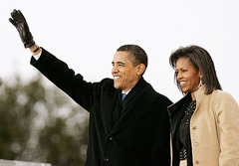  Where is Obama?
- The bird is on the chair.  - (OP) | 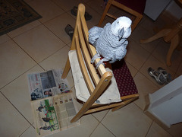  Where is the bird?
- The monster is on the bed.  - (OP) | 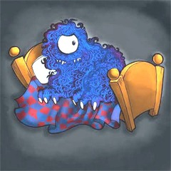  Where is the monster?
- The penguin is on the polar bear.  - (OP) | 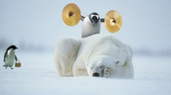  Where is the penguin?
- The cup is on the table.  - (OP) | 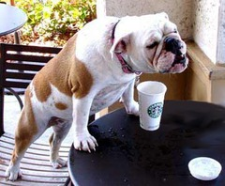  Where is the cup?
- The cup is on the dog's head.  - (OP) | 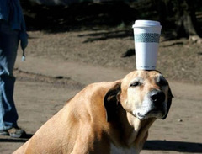  Where is the cup?
- The monster is under the bed.  - (0NDER) | 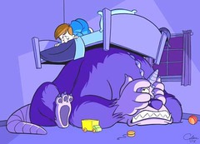  Where is the monster?

